LAB EXPERMIENTS
OPERATING SYSTEM - CSA0460

NAME: RASHMITHA SENTHIL KUMAR
REG NO: 192525034
BRANCH: B. TECH AIML

Experiment No: 1

Aim:
To create a new process using fork() system call and display the Process ID (PID) of the current process and its Parent Process ID (PPID) using a C program.

Algorithm:
Step 1: Start
Step 2: Include required header files
Step 3: Create a new process using fork()
Step 4: Check whether process creation is successful
Step 5: If child process, display Child PID and Parent PID
Step 6: If parent process, display Parent PID and Child PID
Step 7: Stop

Source code:

#include <stdio.h>
#include <unistd.h>
int main() {
pid_t pid;
pid = fork()
if (pid < 0) {
printf("Fork failed\n");
}
else if (pid == 0) {
printf("Child Process\n");
printf("Child PID: %d\n", getpid());
printf("Parent PID: %d\n", getppid());
}
else {
printf("Parent Process\n");
printf("Parent PID: %d\n", getpid());
printf("Child PID: %d\n", pid);
}
return 0;
}

Output:
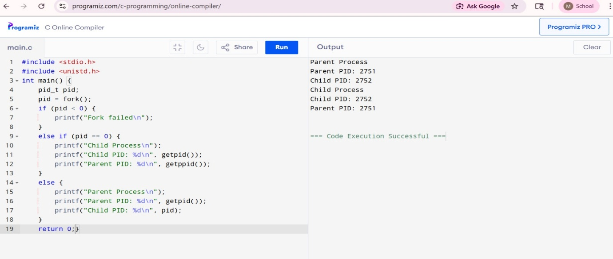
Result: The fork() system call was successfully executed. Parent and child processes were created, and their respective Process IDs (PID) and Parent Process IDs (PPID) were displayed correctly.
Experiment No: 2

Aim:
To implement First Come First Serve (FCFS) CPU Scheduling Algorithm and calculate Waiting Time (WT) and Turnaround Time (TAT) for each process.

Algorithm:

Step 1: Start
Step 2: Enter number of processes
Step 3: Enter burst time for each process
Step 4: Set waiting time of first process as 0
Step 5: Calculate waiting time for remaining processes
Step 6: Calculate turnaround time for each process
Step 7: Display Process, BT, WT and TAT
Step 8: Stop

Source code:

#include <stdio.h>
int main() {
int n, i;
int bt[10], wt[10], tat[10];
printf("Enter number of processes: ");
scanf("%d", &n);
printf("Enter burst time:\n");
for(i = 0; i < n; i++) {
scanf("%d", &bt[i]);
}
wt[0] = 0;

for(i = 1; i < n; i++) {
wt[i] = wt[i-1] + bt[i-1];
}
for(i = 0; i < n; i++) {
tat[i] = wt[i] + bt[i];
}
printf("\nProcess BT WT TAT\n");

for(i = 0; i < n; i++) {
printf("P%d %d %d %d\n", i+1, bt[i], wt[i], tat[i]);
}
return 0;
}

Output:
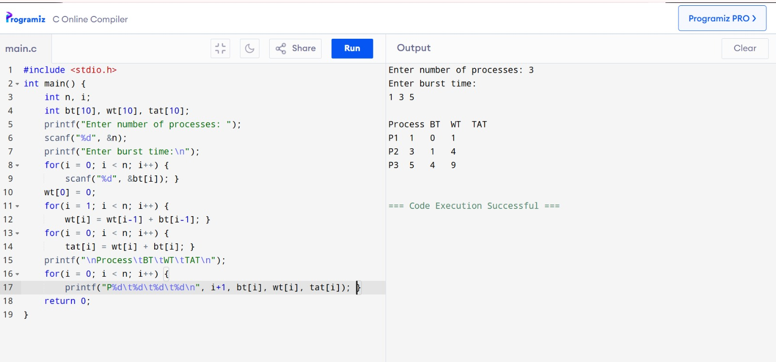
Result:
The FCFS CPU Scheduling Algorithm was successfully implemented, and the Waiting Time (WT) and Turnaround Time (TAT) for all processes were calculated correctly.

Experiment no: 3

Aim:
To illustrate the concept of multithreading by creating and executing multiple threads simultaneously using a C program.

Algorithm:

Step 1: Start
Step 2: Include header files
Step 3: Create thread function 1
Step 4: Create thread function 2
Step 5: Create two threads using pthread_create()
Step 6: Execute threads concurrently
Step 7: Wait for completion using pthread_join()
Step 8: Display output
Step 9: Stop

Source code:

#include <stdio.h>
#include <pthread.h>
#include <unistd.h>
// Function executed by Thread 1
void* task1(void* arg)
{
for(int i = 1; i <= 5; i++)
{
printf("Thread 1: %d\n", i);
sleep(1);
}
return NULL;
}
// Function executed by Thread 2
void* task2(void* arg)
{
for(int i = 1; i <= 5; i++)
{
printf("Thread 2: %d\n", i);
sleep(1);
}
return NULL;
}
int main()
{
pthread_t t1, t2;
// Create threads
pthread_create(&t1, NULL, task1, NULL);
pthread_create(&t2, NULL, task2, NULL);
// Wait for threads to finish
pthread_join(t1, NULL);
pthread_join(t2, NULL);
printf("Both threads finished execution\n");
return 0;
}
Output:
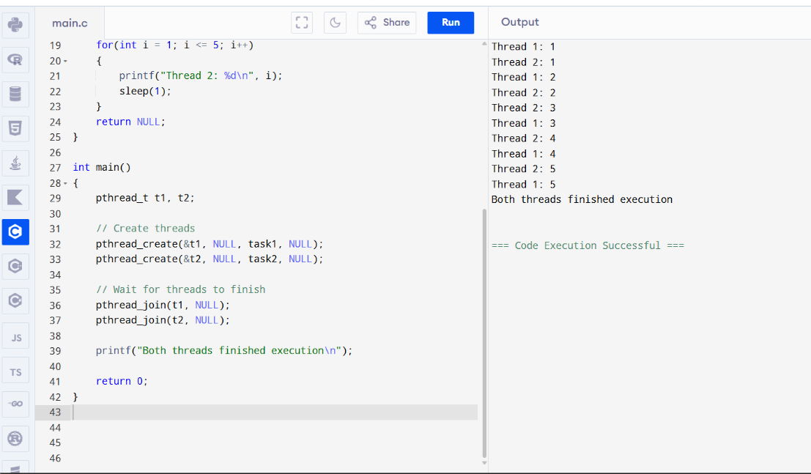
Result:
Multithreading was successfully implemented using pthreads, and multiple threads executed concurrently with proper synchronization.

Experiment no:4

Aim:
To illustrate the concept of inter-process communication using shared memory with a C program.

Algorithm:

Step 1: Start
Step 2: Create shared memory
Step 3: Check memory creation
Step 4: Create child process using fork()
Step 5: Parent writes data into shared memory
Step 6: Child reads data from shared memory
Step 7: Display output
Step 8: Release shared memory
Step 9: Stop

Source code:

#include <stdio.h>
#include <stdlib.h>
#include <string.h>
#include <unistd.h>
#include <sys/mman.h>
#include <sys/wait.h>

int main() {
char *shared_memory;

// Create shared memory
shared_memory = mmap(NULL, 1024, PROT_READ | PROT_WRITE,
MAP_SHARED | MAP_ANONYMOUS, -1, 0);

if (shared_memory == MAP_FAILED) {
perror("Shared memory creation failed");
exit(1);
}

// Create child process
pid_t pid = fork();

if (pid < 0) {
printf("Process creation failed\n");
exit(1);
}
else if (pid == 0) {
// Child process reads from shared memory
sleep(1);
printf("Child Process Read: %s\n", shared_memory);
}
else {
// Parent process writes to shared memory
strcpy(shared_memory, "Hello Child, this is Parent using Shared Memory!");

printf("Parent Process Wrote: %s\n", shared_memory);

// Wait for child process
wait(NULL);

// Remove shared memory
munmap(shared_memory, 1024);
}

return 0;
}

Output:

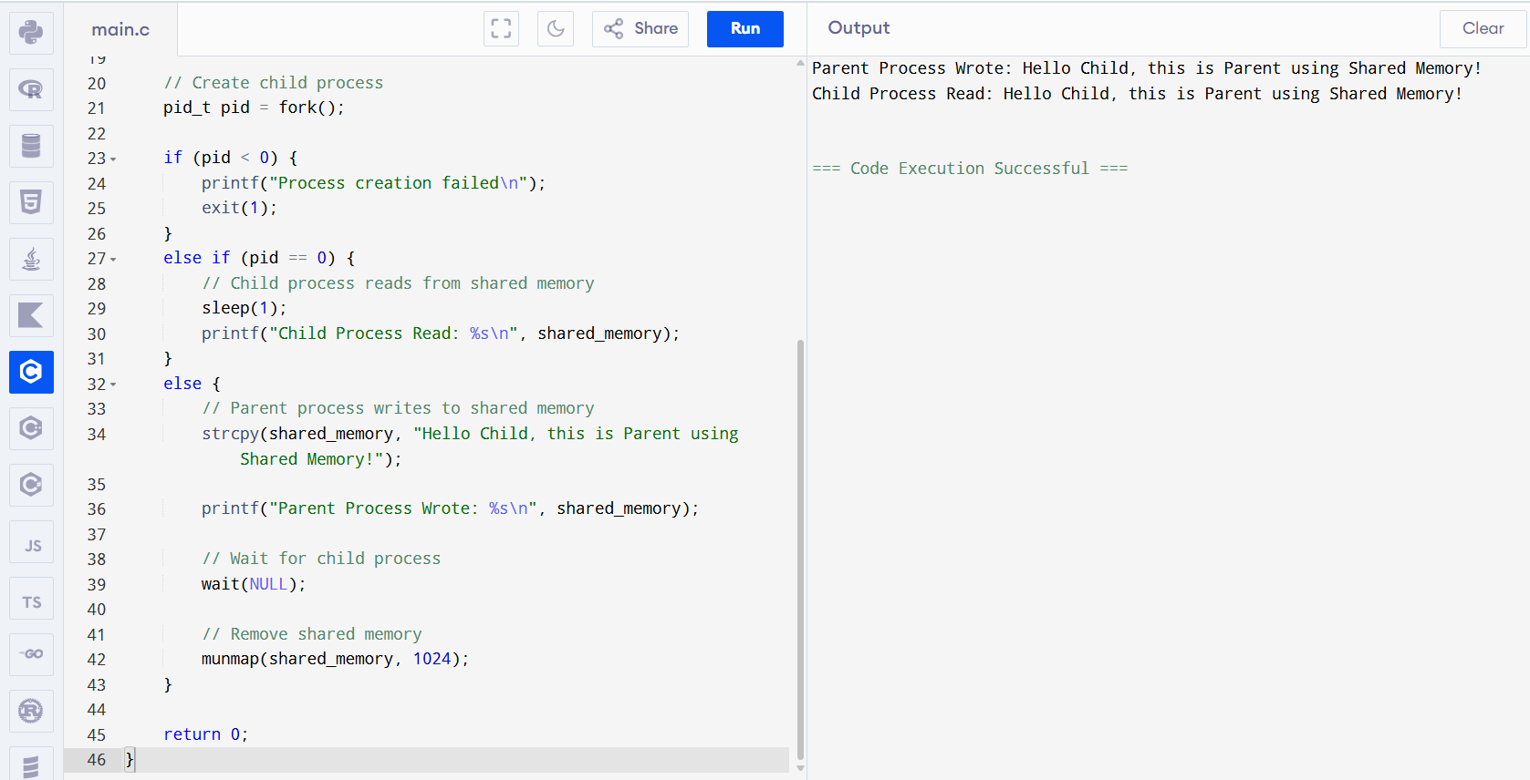

Result:
Inter-process communication using shared memory was successfully implemented, and data was correctly shared between parent and child processes.

Experiment no: 5

Aim:
Illustrate the concept of inter-process communication using message queue with a C program.

Algorithm:

Step 1: Start
Step 2: Define message structure
Step 3: Generate unique key using ftok()
Step 4: Create message queue using msgget()
Step 5: Enter message from user
Step 6: Send message using msgsnd()
Step 7: Receive message using msgrcv()
Step 8: Display received message
Step 9: Delete message queue
Step 10: Stop

Source code:

#include <stdio.h>
#include <sys/ipc.h>
#include <sys/msg.h>
#include <string.h>

// Message structure
struct msg_buffer {
long msg_type;
char msg_text[100];
};

int main() {
key_t key;
int msgid;
struct msg_buffer message;

// Generate unique key
key = ftok("progfile", 65);

// Create message queue
msgid = msgget(key, 0666 | IPC_CREAT);

printf("Message Queue Created!\n");

// ----------- SENDER -----------
message.msg_type = 1;

printf("Enter message: ");
fgets(message.msg_text, 100, stdin);

// Send message
msgsnd(msgid, &message, sizeof(message.msg_text), 0);
printf("Message sent!\n");

// ----------- RECEIVER -----------
msgrcv(msgid, &message, sizeof(message.msg_text), 1, 0);

printf("Message received: %s", message.msg_text);

// Delete message queue
msgctl(msgid, IPC_RMID, NULL);

return 0;
}

Output:
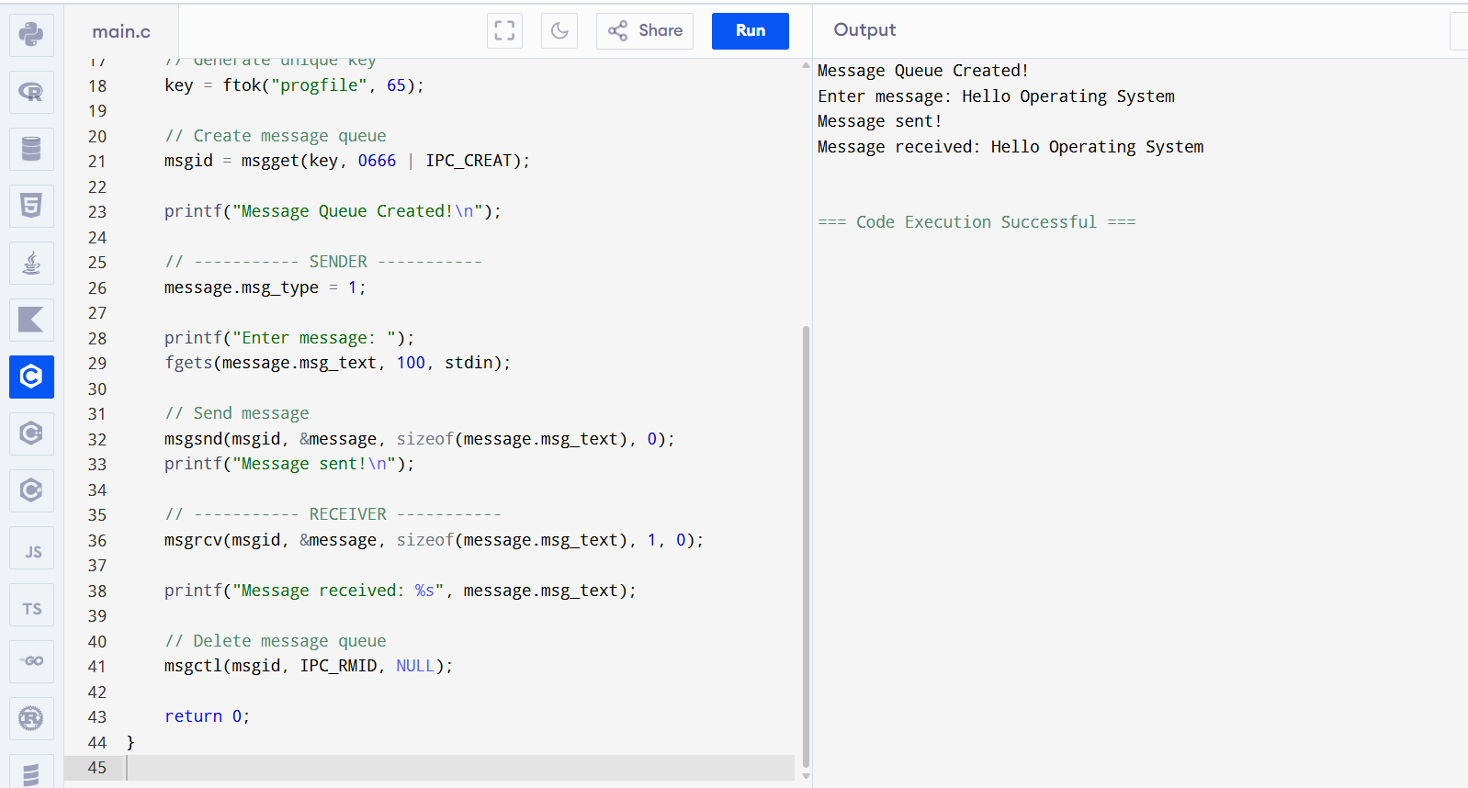

Result:
Inter-process communication using message queue was successfully implemented, and messages were successfully sent and received between processes.

Experiment No:6

Aim:

To illustrate the concept of deadlock avoidance by simulating Banker’s Algorithm using C program.

Algorithm:

Step 1: Start
Step 2: Read number of processes and resources
Step 3: Read Allocation matrix
Step 4: Read Maximum matrix
Step 5: Read Available resources
Step 6: Calculate Need matrix = Max - Allocation
Step 7: Find process whose Need <= Available
Step 8: Add its Allocation to Available and mark process completed
Step 9: Repeat until all processes complete
Step 10: If all complete, print safe sequence; otherwise print Unsafe
Step 11: Stop

Source Code:

#include <stdio.h>
int main(){
int n,m,i,j,k,c=0,f[10]={0},a[10][10],mx[10][10],av[10],nd[10][10],s[10];
scanf("%d%d",&n,&m);
for(i=0;i<n;i++)
for(j=0;j<m;j++)
scanf("%d",&a[i][j]);
for(i=0;i<n;i++)
for(j=0;j<m;j++)
scanf("%d",&mx[i][j]);
for(i=0;i<m;i++)
scanf("%d",&av[i]);
for(i=0;i<n;i++)
for(j=0;j<m;j++)
nd[i][j]=mx[i][j]-a[i][j];
while(c<n){
int found=0;
for(i=0;i<n;i++)
if(!f[i]){
for(j=0;j<m && nd[i][j]<=av[j];j++);
if(j==m){
for(k=0;k<m;k++)
av[k]+=a[i][k];
s[c++]=i;
f[i]=found=1;
}
}
if(!found)
break;
}
if(c==n)
for(i=0;i<n;i++)
printf("P%d ",s[i]);
else
printf("Unsafe");
return 0;
}
Output:
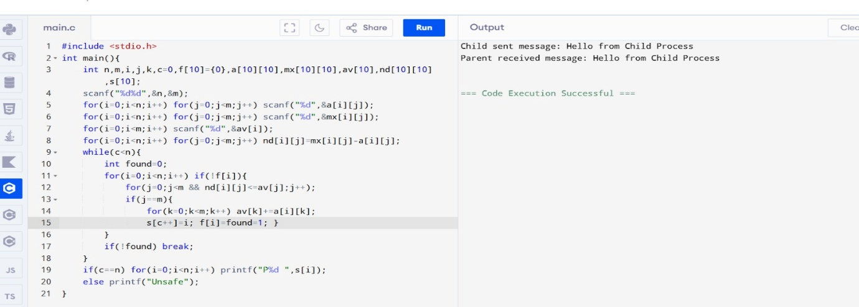
Result:
Banker’s Algorithm was successfully implemented, and the system is found to be in a safe state with the safe sequence:
P1 P3 P4 P0 P2

Experiment no:7

Aim:
To simulate the Producer-Consumer problem using semaphores in C.

Algorithm:
Step 1: Start
Step 2: Initialize empty semaphore e = 1 and full semaphore f = 0
Step 3: Create producer and consumer threads
Step 4: Producer waits for empty, produces item, then signals full
Step 5: Consumer waits for full, consumes item, then signals empty
Step 6: Wait for both threads to complete
Step 7: Stop

Source Code:

#include <stdio.h>
#include <pthread.h>
#include <semaphore.h>
sem_t e, f;
int x = 0;
void *p() {
sem_wait(&e);
x++;
printf("P:%d\n", x);
sem_post(&f);
}
void *c() {
sem_wait(&f);
printf("C:%d\n", x--);
sem_post(&e);
}
int main() {
pthread_t t1, t2;
sem_init(&e, 0, 1);
sem_init(&f, 0, 0);
pthread_create(&t1, 0, p, 0);
pthread_create(&t2, 0, c, 0);
pthread_join(t1, 0);
pthread_join(t2, 0);
return 0;
}

Output:
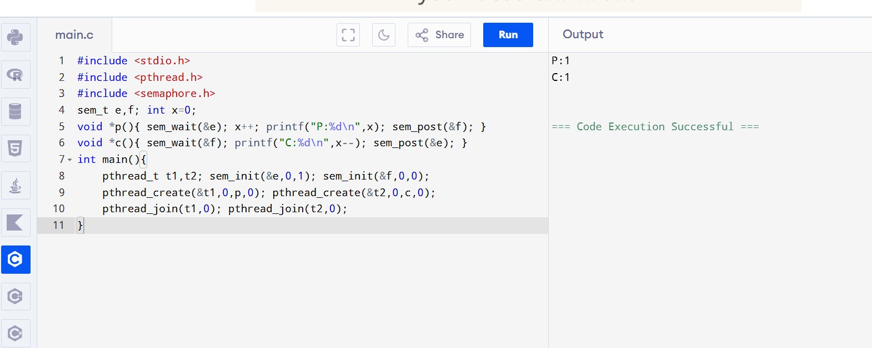

Result:
The Producer-Consumer problem was successfully simulated using semaphores.

Experiment no: 8

Aim:
To implement process/thread synchronization using mutex locks in C.

Algorithm:
Step 1: Start
Step 2: Initialize shared variable x = 0
Step 3: Initialize mutex lock
Step 4: Create two threads
Step 5: Each thread locks the mutex
Step 6: Increment shared variable x
Step 7: Display value of x
Step 8: Unlock the mutex
Step 9: Wait for both threads to finish
Step 10: Destroy mutex and stop

Source Code:
#include <stdio.h>
#include <pthread.h>
int x=0;
pthread_mutex_t m;
void *f(void *p){
pthread_mutex_lock(&m);
x++;
printf("Value: %d\n", x);
pthread_mutex_unlock(&m);
}
int main(){
pthread_t t1,t2;
pthread_mutex_init(&m,NULL);
pthread_create(&t1,NULL,f,NULL);
pthread_create(&t2,NULL,f,NULL);
pthread_join(t1,NULL);
pthread_join(t2,NULL);
pthread_mutex_destroy(&m);
}

Output:
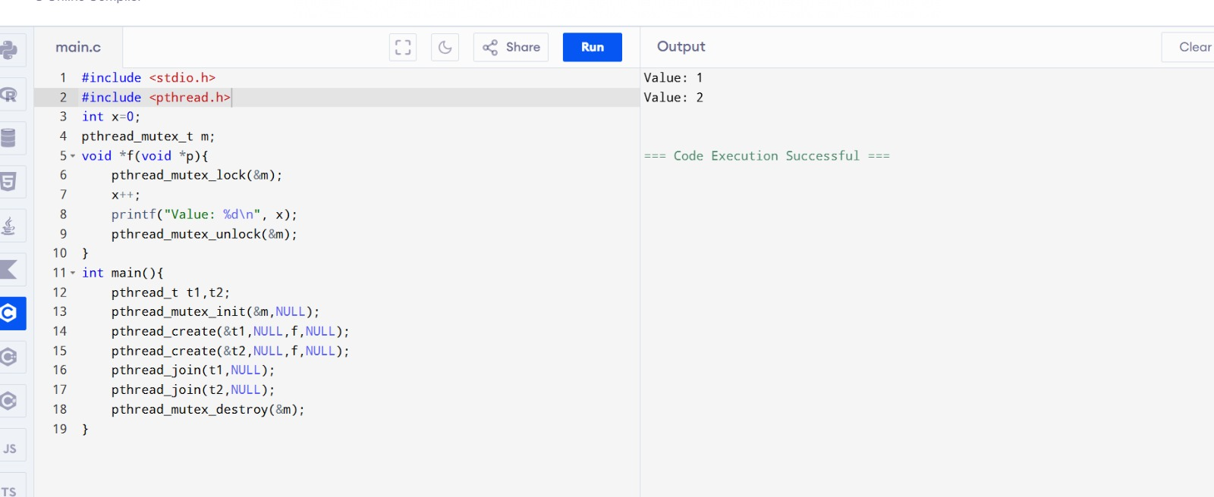

Result:
Process synchronization using mutex locks was successfully implemented.

Experiment no:9

Aim:
To simulate the Reader-Writer problem using semaphores in C.

Algorithm:
Step 1: Start
Step 2: Initialize semaphores m and w
Step 3: Create reader and writer threads
Step 4: Reader increments read count
Step 5: First reader locks writer semaphore
Step 6: Reader performs reading
Step 7: Reader decrements read count
Step 8: Last reader releases writer semaphore
Step 9: Writer locks semaphore, writes, then releases it
Step 10: Stop

Source Code:

#include <stdio.h>
#include <pthread.h>
#include <semaphore.h>
sem_t m,w; int rc=0;
void* r(void* a){
sem_wait(&m); rc++; if(rc==1) sem_wait(&w); sem_post(&m);
printf("Reader\n");
sem_wait(&m); rc--; if(rc==0) sem_post(&w); sem_post(&m);
}
void* wr(void* a){
sem_wait(&w); printf("Writer\n"); sem_post(&w);
}
int main(){
pthread_t t1,t2,t3;
sem_init(&m,0,1); sem_init(&w,0,1);
pthread_create(&t1,0,r,0); pthread_create(&t2,0,r,0); pthread_create(&t3,0,wr,0);
pthread_join(t1,0); pthread_join(t2,0); pthread_join(t3,0);
}
Output:
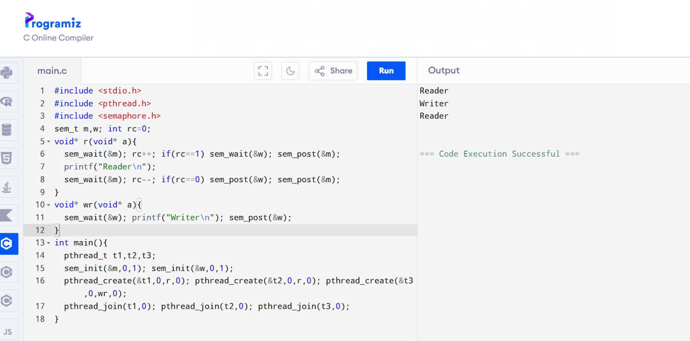

Result:
Reader-Writer problem was successfully simulated using semaphores.

Experiment no :10

Aim:
To simulate the concept of Dining Philosophers problem using mutex locks in C.

Algorithm:
Step 1: Start
Step 2: Initialize 5 mutex locks for 5 forks
Step 3: Create 5 philosopher threads
Step 4: Each philosopher tries to pick left and right fork
Step 5: Odd philosophers pick left first, even philosophers pick right first
Step 6: Philosopher eats after getting both forks
Step 7: Release both forks after eating
Step 8: Wait for all philosopher threads to finish
Step 9: Stop

Source Code:

#include <pthread.h>
#include <stdio.h>
#define N 5
pthread_mutex_t f[N];
void* phil(void* arg) {
int i = *(int*)arg, l = i, r = (i + 1) % N;
if(i % 2) {
pthread_mutex_lock(&f[l]);
pthread_mutex_lock(&f[r]);
}
else {
pthread_mutex_lock(&f[r]);
pthread_mutex_lock(&f[l]);
}
printf("Philosopher %d eating\n", i);
pthread_mutex_unlock(&f[l]);
pthread_mutex_unlock(&f[r]);
return NULL;
}
int main() {
pthread_t t[N];
int a[N];
for(int i = 0; i < N; i++)
pthread_mutex_init(&f[i], NULL);
for(int i = 0; i < N; i++) {
a[i] = i;
pthread_create(&t[i], NULL, phil, &a[i]);
}
for(int i = 0; i < N; i++)
pthread_join(t[i], NULL);
return 0;
}

Output:
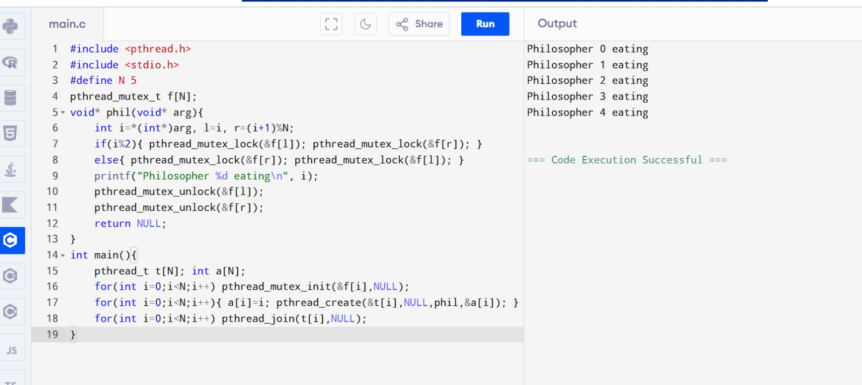

Result:
Dining Philosophers problem was successfully simulated using mutex locks, and all philosophers were able to eat without deadlock.

Experiment No: 11

Aim:
To implement the First Fit Memory Management Algorithm using a C program.

Algorithm:
Step 1: Start
Step 2: Enter the number of memory blocks
Step 3: Enter the size of each memory block
Step 4: Enter the number of processes
Step 5: Enter the size of each process
Step 6: Initialize allocation array as -1
Step 7: Allocate each process to the first suitable memory block
Step 8: Reduce the remaining memory size after allocation
Step 9: Display process allocation details
Step 10: Stop

Source Code:

#include <stdio.h>
int main() {
int blockSize[10], processSize[10];
int allocation[10];
int nb, np;
int i, j;

printf("Enter number of memory blocks: ");
scanf("%d", &nb);

printf("Enter size of each memory block:\n");
for (i = 0; i < nb; i++) {
scanf("%d", &blockSize[i]);
}

printf("Enter number of processes: ");
scanf("%d", &np);

printf("Enter size of each process:\n");
for (i = 0; i < np; i++) {
scanf("%d", &processSize[i]);
allocation[i] = -1;
}

// First Fit Algorithm
for (i = 0; i < np; i++) {
for (j = 0; j < nb; j++) {
if (blockSize[j] >= processSize[i]) {
allocation[i] = j;
blockSize[j] = blockSize[j] - processSize[i];
break;
}
}
}

printf("\nProcess No.\tProcess Size\tBlock No.\n");

for (i = 0; i < np; i++) {
printf("%d\t\t%d\t\t", i + 1, processSize[i]);

if (allocation[i] != -1)
printf("%d\n", allocation[i] + 1);
else
printf("Not Allocated\n");
}

return 0;
}

Output:
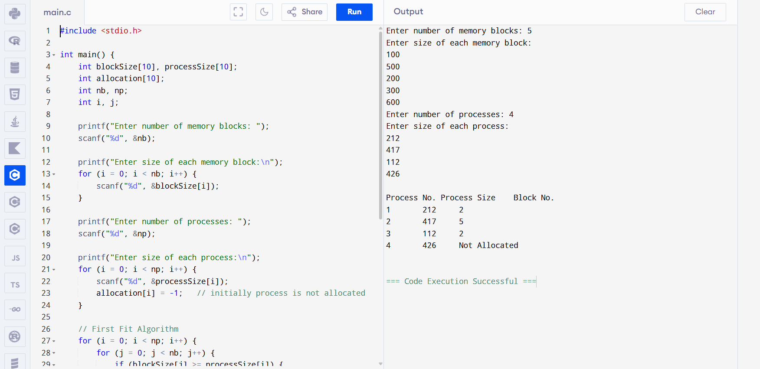

Result:
The First Fit Memory Management Algorithm was successfully implemented, and the processes were allocated to the first suitable memory blocks correctly.

Experiment no :12

Aim:
To implement the Best Fit Memory Management Algorithm using a C program.

Algorithm:
Step 1: Start
Step 2: Enter the number of memory blocks
Step 3: Enter the size of each memory block
Step 4: Enter the number of processes
Step 5: Enter the size of each process
Step 6: Initialize allocation array as -1
Step 7: Find the smallest suitable memory block for each process
Step 8: Allocate process to the best suitable block
Step 9: Reduce the remaining block size after allocation
Step 10: Display process allocation details
Step 11: Stop

Source Code:

#include <stdio.h>

int main() {
int blockSize[10], processSize[10];
int allocation[10];
int nb, np;
int i, j, bestIdx;

printf("Enter number of memory blocks: ");
scanf("%d", &nb);

printf("Enter size of each block:\n");
for (i = 0; i < nb; i++) {
scanf("%d", &blockSize[i]);
}

printf("Enter number of processes: ");
scanf("%d", &np);

printf("Enter size of each process:\n");
for (i = 0; i < np; i++) {
scanf("%d", &processSize[i]);
allocation[i] = -1;
}

// Best Fit Algorithm
for (i = 0; i < np; i++) {
bestIdx = -1;

for (j = 0; j < nb; j++) {
if (blockSize[j] >= processSize[i]) {
if (bestIdx == -1 || blockSize[j] < blockSize[bestIdx]) {
bestIdx = j;
}
}
}

if (bestIdx != -1) {
allocation[i] = bestIdx;
blockSize[bestIdx] -= processSize[i];
}
}

printf("\nProcess No\tProcess Size\tBlock No\n");

for (i = 0; i < np; i++) {
printf("%d\t\t%d\t\t", i + 1, processSize[i]);

if (allocation[i] != -1)
printf("%d\n", allocation[i] + 1);
else
printf("Not Allocated\n");
}

return 0;
}

Output:
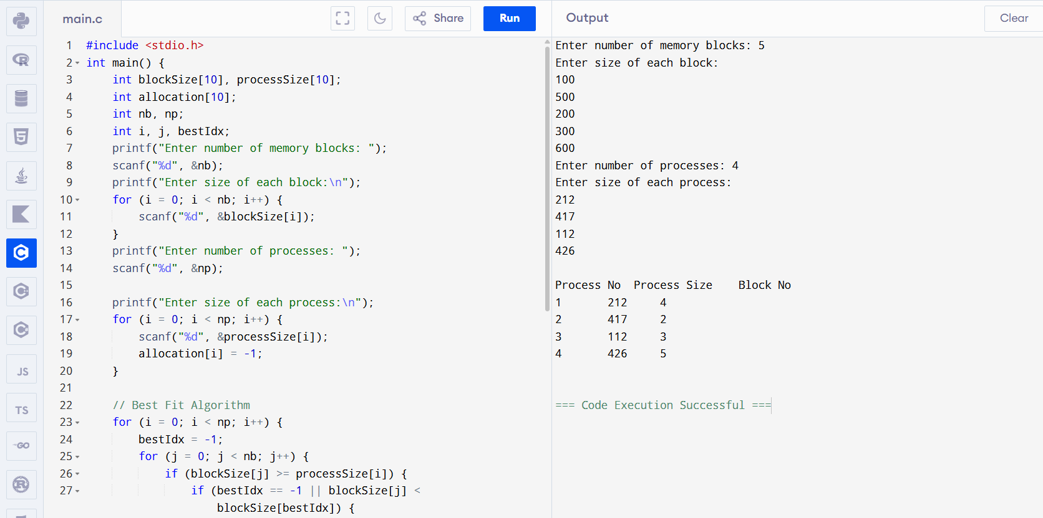

Result:
The Best Fit Memory Management Algorithm was successfully implemented, and the processes were allocated to the most suitable memory blocks correctly.

Experiment No: 13

Aim:
To implement the Worst Fit Memory Management Algorithm using a C program.

Algorithm:
Step 1: Start
Step 2: Enter the number of memory blocks
Step 3: Enter the size of each memory block
Step 4: Enter the number of processes
Step 5: Enter the size of each process
Step 6: Initialize allocation array as -1
Step 7: Find the largest suitable memory block for each process
Step 8: Allocate process to the worst suitable block
Step 9: Reduce the remaining block size after allocation
Step 10: Display process allocation details
Step 11: Stop

Source Code:

#include <stdio.h>
int main() {
int blockSize[10], processSize[10];
int allocation[10];
int nb, np;
int i, j, worstIdx;

printf("Enter number of memory blocks: ");
scanf("%d", &nb);

printf("Enter size of each block:\n");
for (i = 0; i < nb; i++) {
scanf("%d", &blockSize[i]);
}

printf("Enter number of processes: ");
scanf("%d", &np);

printf("Enter size of each process:\n");
for (i = 0; i < np; i++) {
scanf("%d", &processSize[i]);
allocation[i] = -1;
}

// Worst Fit Algorithm
for (i = 0; i < np; i++) {
worstIdx = -1;

for (j = 0; j < nb; j++) {
if (blockSize[j] >= processSize[i]) {
if (worstIdx == -1 || blockSize[j] > blockSize[worstIdx]) {
worstIdx = j;
}
}
}

if (worstIdx != -1) {
allocation[i] = worstIdx;
blockSize[worstIdx] -= processSize[i];
}
}

printf("\nProcess No\tProcess Size\tBlock No\n");

for (i = 0; i < np; i++) {
printf("%d\t\t%d\t\t", i + 1, processSize[i]);

if (allocation[i] != -1)
printf("%d\n", allocation[i] + 1);
else
printf("Not Allocated\n");
}

return 0;
}

Output:
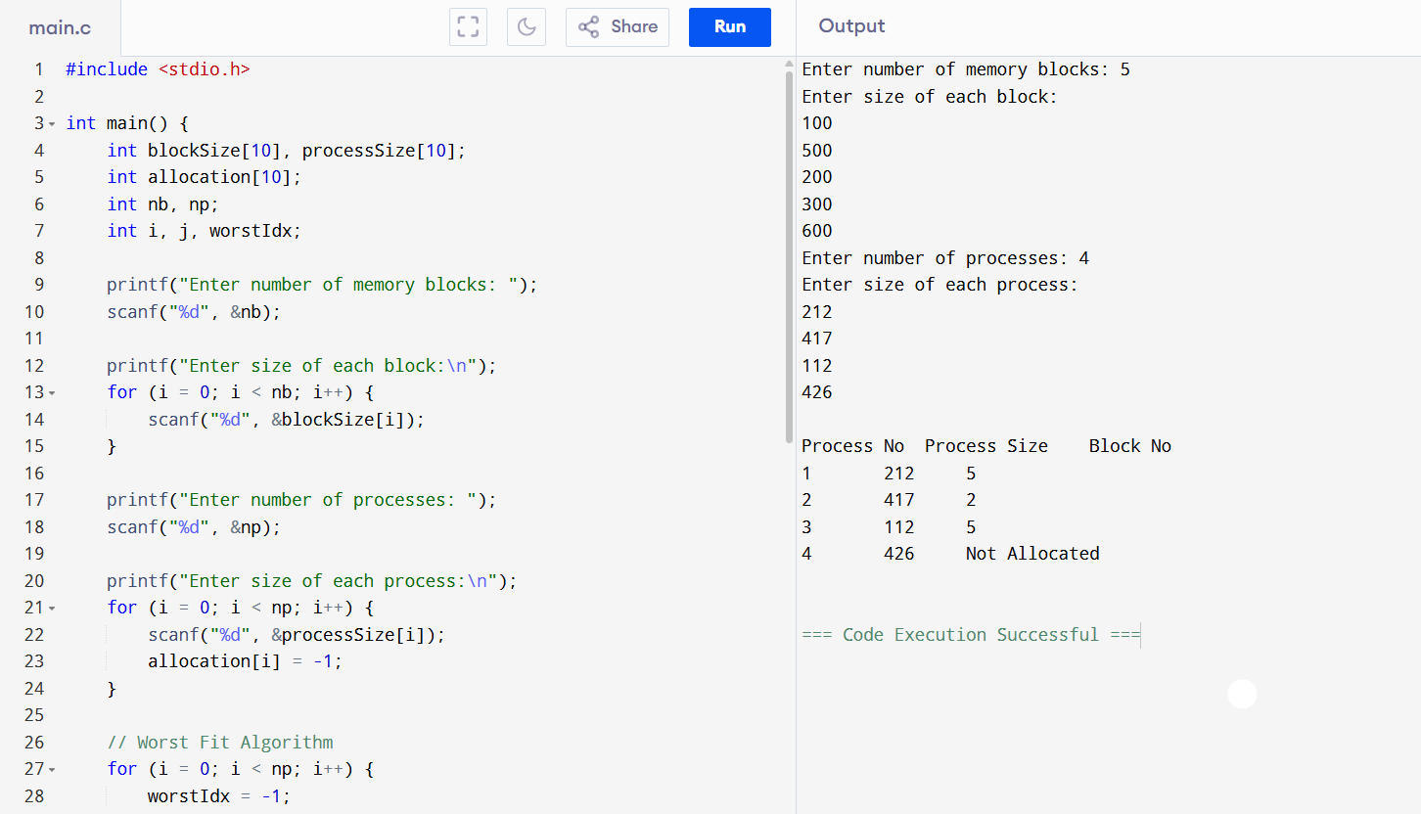

Result:
The Worst Fit Memory Management Algorithm was successfully implemented, and the processes were allocated to the largest suitable memory blocks correctly.

Experiment No: 14

Aim:
To identify the system calls used to copy the contents of one file to another and implement them using a C program.

Algorithm:
Step 1: Start
Step 2: Open the source file in read mode using open()
Step 3: Create/open the destination file using open()
Step 4: Read data from source file using read()
Step 5: Write data into destination file using write()
Step 6: Repeat until end of file is reached
Step 7: Close both files using close()
Step 8: Display success message
Step 9: Stop

Source Code:

#include <stdio.h>
#include <fcntl.h>
#include <unistd.h>
int main() {
int src, dest;
char buffer[100];
int bytes;

// Open source file
src = open("Source.txt", O_RDONLY);

if (src < 0) {
perror("Error opening source file");
return 1;
}

// Create destination file
dest = open("Dest.txt", O_WRONLY | O_CREAT | O_TRUNC, 0644);
if (dest < 0) {
perror("Error creating destination file");
return 1;
}
// Copy content
while ((bytes = read(src, buffer, sizeof(buffer))) > 0) {
write(dest, buffer, bytes);
}
close(src);
close(dest);
printf("File copied successfully!\n");
return 0;
}

Output:
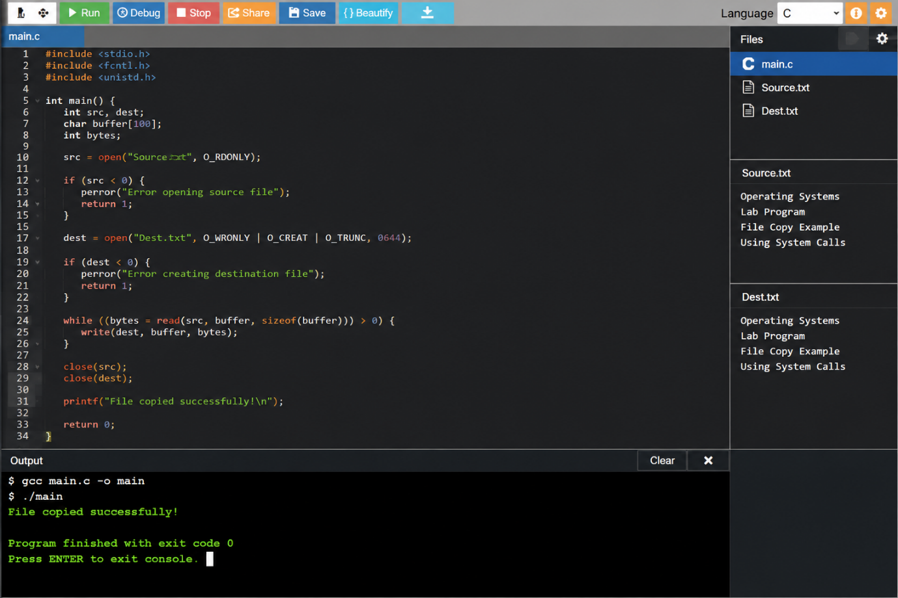

Result:
The contents of one file were successfully copied to another file using the system calls open(), read(), write(), and close().

Experiment No: 15

Aim:
To write a C program to demonstrate thread related concepts such as create, join, equal, and exit using pthreads.

Algorithm:
Step 1: Start
Step 2: Include the required header files
Step 3: Define a thread function
Step 4: Get the current thread ID using pthread_self()
Step 5: Create two threads using pthread_create()
Step 6: Check whether two threads are equal using pthread_equal()
Step 7: Wait for both threads to complete using pthread_join()
Step 8: Exit from the thread using pthread_exit()
Step 9: Display the output
Step 10: Stop

Source Code:
#include <stdio.h>
#include <pthread.h>
void* threadFunction(void* arg) {
pthread_t currentThread;
currentThread = pthread_self();
printf("Thread is running...\n");
printf("Thread ID: %lu\n", currentThread);
pthread_exit(NULL);
}
int main() {
pthread_t t1, t2;
// Create threads
pthread_create(&t1, NULL, threadFunction, NULL);
pthread_create(&t2, NULL, threadFunction, NULL);
// Check whether two threads are equal
if(pthread_equal(t1, t2)) {
printf("Both threads are equal\n");
} else {
printf("Threads are not equal\n");
}
// Wait for threads to finish
pthread_join(t1, NULL);
pthread_join(t2, NULL);
printf("Both threads completed\n");
pthread_exit(NULL);
}

Output:
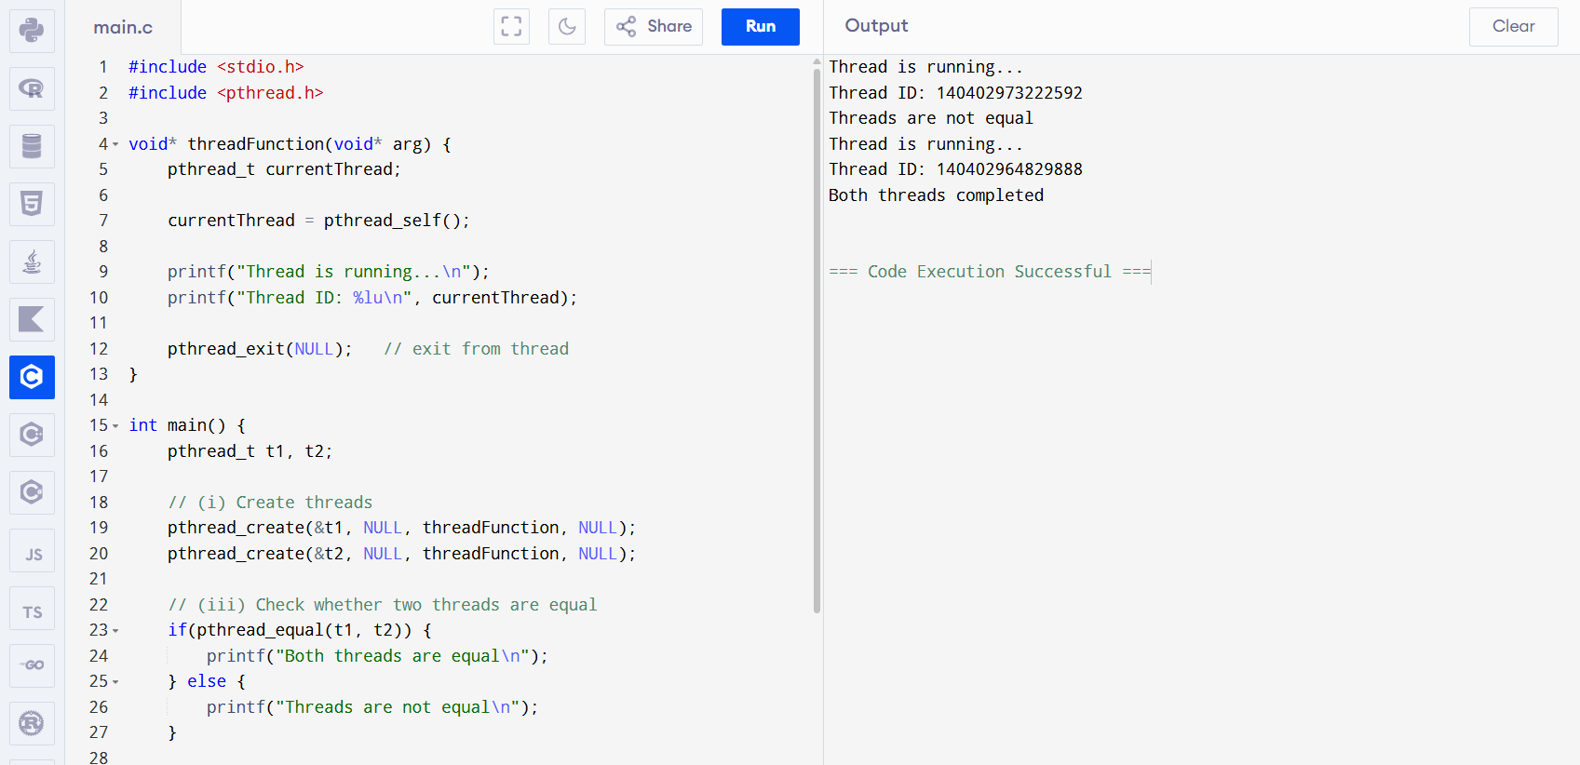

Result:
The thread related concepts such as create, join, equal, and exit were successfully demonstrated using pthread functions.

Experiment No: 16
Aim:
To write a C program to organize files using a single level directory structure.

Algorithm:
Step 1: Start
Step 2: Display menu options: Create, Copy, and Delete
Step 3: Read the user choice
Step 4: If choice is 1, create a file using fopen()
Step 5: If choice is 2, open source and destination files using open()
Step 6: Copy contents using read() and write()
Step 7: If choice is 3, delete the file using remove()
Step 8: Display the appropriate message
Step 9: Stop

Source Code:
#include <stdio.h>
#include <stdlib.h>
#include <fcntl.h>
#include <unistd.h>

#define BUFFER_SIZE 4096

void copy() {
const char *sourcefile = "C:/Users/vivek balaji/OneDrive/Desktop/Source.txt";
const char *destination_file = "C:/Users/vivek balaji/OneDrive/Desktop/Dest.txt";

int source_fd = open(sourcefile, O_RDONLY);
int dest_fd = open(destination_file, O_WRONLY | O_CREAT | O_TRUNC, 0666);

char buffer[BUFFER_SIZE];
ssize_t bytesRead, bytesWritten;

while ((bytesRead = read(source_fd, buffer, BUFFER_SIZE)) > 0) {
bytesWritten = write(dest_fd, buffer, bytesRead);
}

close(source_fd);
close(dest_fd);

printf("File copied successfully.\n");
}

void create() {
FILE *fp;

fp = fopen("C:/Users/vivek balaji/OneDrive/Desktop/Source.txt", "w");

if (fp != NULL) {
printf("File created successfully\n");
fclose(fp);
}
}

int main() {
int n;

printf("1. Create \t2. Copy \t3. Delete\nEnter your choice: ");
scanf("%d", &n);

switch(n) {
case 1:
create();
break;

case 2:
copy();
break;

case 3:
remove("C:/Users/vivek balaji/OneDrive/Desktop/Source.txt");
printf("Deleted successfully\n");
break;
}

return 0;
}

Output:
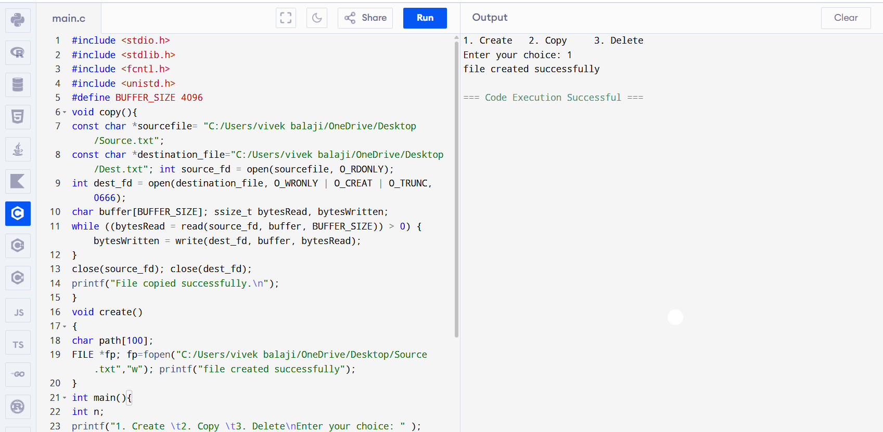

Result:
The single level directory file organization was successfully implemented, and file operations such as create, copy, and delete were performed correctly.
Experiment No: 17

Aim:
To simulate the First Come First Served (FCFS) Disk Scheduling Algorithm using a C program.

Algorithm:
Step 1: Start
Step 2: Enter the number of disk requests
Step 3: Enter the disk request sequence
Step 4: Enter the initial head position
Step 5: Move the disk head according to FCFS order
Step 6: Calculate total head movement
Step 7: Display the disk scheduling order
Step 8: Display total head movement
Step 9: Stop

Source Code:
#include <stdio.h>
#include <stdlib.h>
int main()
{
int n, head, i;
int request[20];
int total_movement = 0;
printf("Enter number of disk requests: ");
scanf("%d", &n);
printf("Enter disk request sequence:\n");
for(i = 0; i < n; i++)
{
scanf("%d", &request[i]);
}
printf("Enter initial head position: ");
scanf("%d", &head);
printf("\nFCFS Disk Scheduling Order:\n");
printf("%d", head);
for(i = 0; i < n; i++)
{
total_movement += abs(request[i] - head);
head = request[i];
printf(" -> %d", head);
}
printf("\n\nTotal Head Movement = %d\n", total_movement);
return 0;
}

Output:
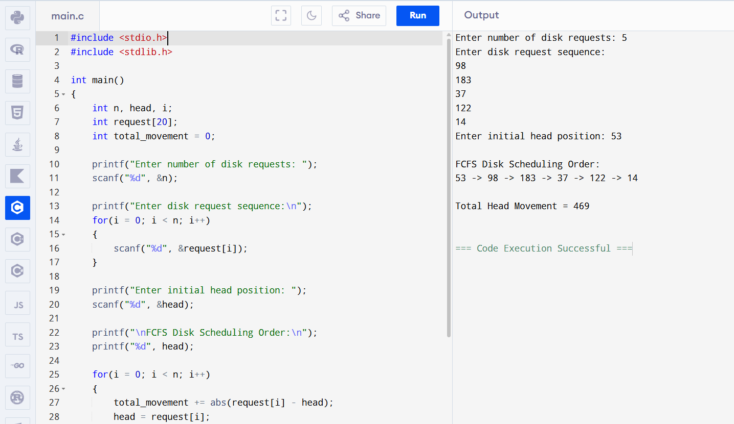

Result:
The First Come First Served (FCFS) Disk Scheduling Algorithm was successfully simulated, and the total head movement was calculated correctly.

Experiment No: 18
Aim:
To simulate the SCAN Disk Scheduling Algorithm using a C program.

Algorithm:
Step 1: Start
Step 2: Enter the number of disk requests
Step 3: Enter the disk request sequence
Step 4: Enter the initial head position
Step 5: Enter disk size and direction
Step 6: Sort the disk request sequence
Step 7: Move the head in the given direction and service requests
Step 8: After reaching one end, reverse the direction
Step 9: Calculate total head movement
Step 10: Display SCAN order and total head movement
Step 11: Stop

Source Code:
#include <stdio.h>
#include <stdlib.h>
int main()
{
int n, head, size, direction;
int request[20], i, j, temp;
int total_movement = 0;
printf("Enter number of requests: ");
scanf("%d", &n);
printf("Enter request sequence:\n");
for(i = 0; i < n; i++)
scanf("%d", &request[i]);
printf("Enter initial head position: ");
scanf("%d", &head);
printf("Enter disk size: ");
scanf("%d", &size);
printf("Enter direction (0 = left, 1 = right): ");
scanf("%d", &direction);
// Sort requests
for(i = 0; i < n; i++)
{
for(j = i + 1; j < n; j++)
{
if(request[i] > request[j])
{
temp = request[i];
request[i] = request[j];
request[j] = temp;
}
}
}
printf("\nSCAN Order:\n");
if(direction == 1)
{
for(i = 0; i < n; i++)
{
if(request[i] >= head)
{
printf("%d -> ", request[i]);
total_movement += abs(request[i] - head);
head = request[i];
}
}
total_movement += abs((size - 1) - head);
head = size - 1;

for(i = n - 1; i >= 0; i--)
{
if(request[i] < head)
{
printf("%d -> ", request[i]);
total_movement += abs(request[i] - head);
head = request[i];
}
}
}
else
{
for(i = n - 1; i >= 0; i--)
{
if(request[i] <= head)
{
printf("%d -> ", request[i]);
total_movement += abs(request[i] - head);
head = request[i];
}
}

total_movement += abs(head - 0);
head = 0;
for(i = 0; i < n; i++)
{
if(request[i] > head)
{
printf("%d -> ", request[i]);
total_movement += abs(request[i] - head);
head = request[i];
}
}
}

printf("\nTotal Head Movement = %d\n", total_movement);
return 0;
}

Output:
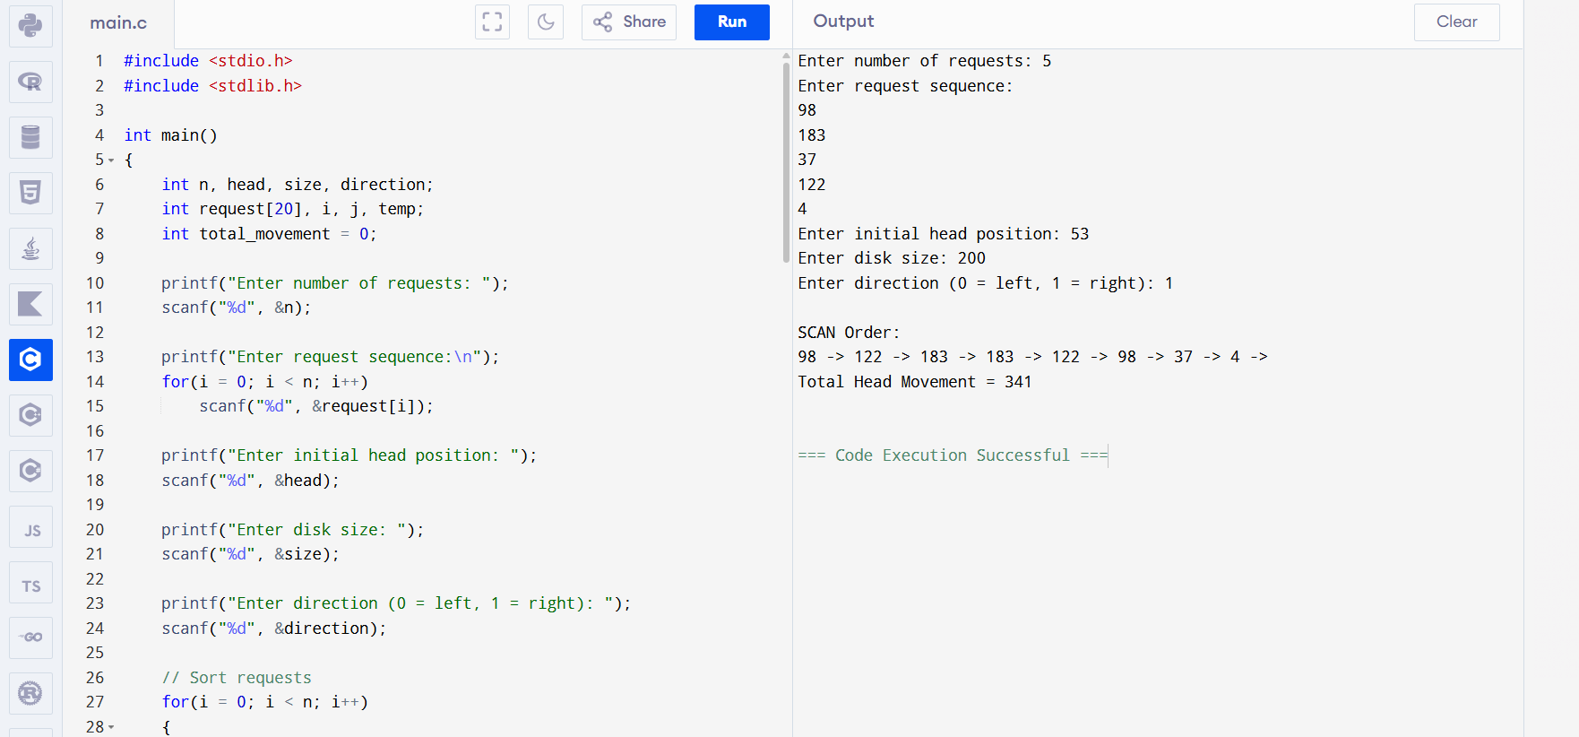

Result:
The SCAN Disk Scheduling Algorithm was successfully simulated, and the total head movement was calculated correctly.

Experiment No: 19

Aim:
To simulate the C-SCAN Disk Scheduling Algorithm using a C program.

Algorithm:
Step 1: Start
Step 2: Enter the number of disk requests
Step 3: Enter the disk request sequence
Step 4: Enter the initial head position
Step 5: Enter the disk size
Step 6: Sort the disk request sequence
Step 7: Service all requests greater than or equal to the head position
Step 8: Move the head to the end of the disk
Step 9: Jump the head to the beginning of the disk
Step 10: Service the remaining requests
Step 11: Calculate and display total head movement
Step 12: Stop

Source Code:

#include <stdio.h>
#include <stdlib.h>
int main()
{
int n, head, size, i, j, temp;
int request[20];
int total_movement = 0;
printf("Enter number of requests: ");
scanf("%d", &n);
printf("Enter request sequence:\n");
for(i = 0; i < n; i++)
scanf("%d", &request[i]);

printf("Enter initial head position: ");
scanf("%d", &head);
printf("Enter disk size: ");
scanf("%d", &size);
// Sort requests
for(i = 0; i < n; i++)
{
for(j = i + 1; j < n; j++)
{
if(request[i] > request[j])
{
temp = request[i];
request[i] = request[j];
request[j] = temp;
}
}
}
printf("\nC-SCAN Order:\n");
// Move right
for(i = 0; i < n; i++)
{
if(request[i] >= head)
{
printf("%d -> ", request[i]);
total_movement += abs(request[i] - head);
head = request[i];
}
}

// Go to end of disk
total_movement += abs((size - 1) - head);
head = size - 1;
// Jump to beginning
total_movement += abs(head - 0);
head = 0;
// Continue servicing remaining requests
for(i = 0; i < n; i++)
{
if(request[i] < head)
{
printf("%d -> ", request[i]);
total_movement += abs(request[i] - head);
head = request[i];
}
}
printf("\nTotal Head Movement = %d\n", total_movement)
return 0;
}

Output:
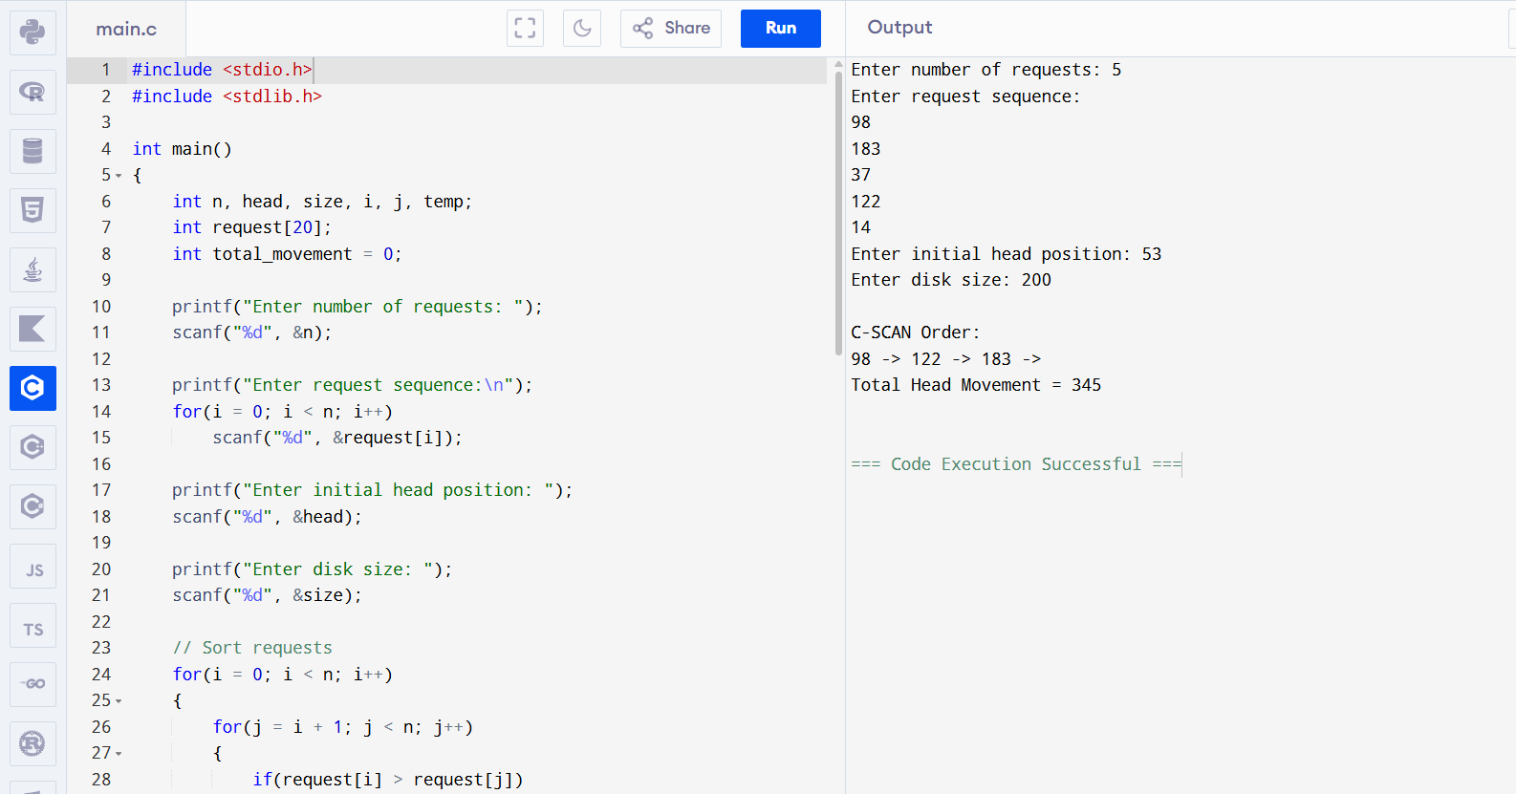

Result:
The C-SCAN Disk Scheduling Algorithm was successfully simulated, and the total head movement was calculated correctly.
Experiment No: 20

Aim:
To simulate the First In First Out (FIFO) Paging Technique of memory management using a C program.

Algorithm:
Step 1: Start
Step 2: Enter the number of pages
Step 3: Enter the page reference string
Step 4: Enter the number of frames
Step 5: Initialize all frames as -1
Step 6: Check whether the current page is already present in frame
Step 7: If page is not present, replace the oldest page using FIFO method
Step 8: Increase the page fault count
Step 9: Display the frame status for each page
Step 10: Display total page faults
Step 11: Stop

Source Code:
#include <stdio.h>
int main()
{
int pages[50], frame[10];
int n, f, i, j, k, page_faults = 0;
int index = 0, found;
printf("Enter number of pages: ");
scanf("%d", &n);
printf("Enter page reference string:\n");
for(i = 0; i < n; i++)
scanf("%d", &pages[i]);

printf("Enter number of frames: ");
scanf("%d", &f);

// Initialize frames with -1
for(i = 0; i < f; i++)
frame[i] = -1;
printf("\nPage\tFrames\n");
for(i = 0; i < n; i++)
{
found = 0;

// Check if page already in frame
for(j = 0; j < f; j++)
{
if(frame[j] == pages[i])
{
found = 1;
break;
}
}
// If not found, page fault occurs
if(found == 0)
{
frame[index] = pages[i];
index = (index + 1) % f;
page_faults++;
}
// Print frames
printf("%d\t", pages[i]);
for(k = 0; k < f; k++)
printf("%d ", frame[k]);
printf("\n");
}

printf("\nTotal Page Faults = %d\n", page_faults);
return 0;
}

Output:
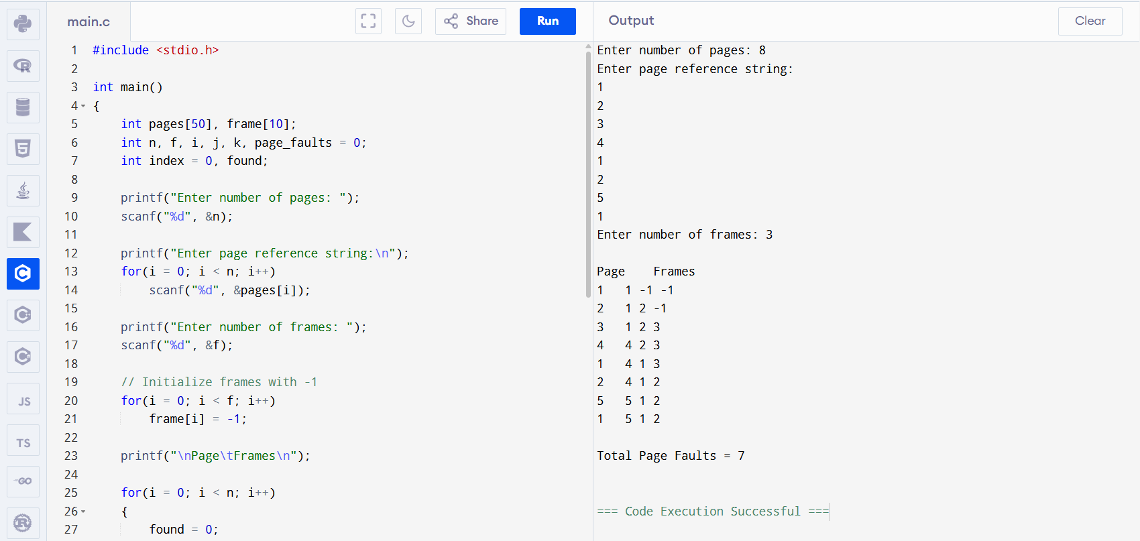

Result:
The First In First Out (FIFO) Paging Technique was successfully simulated, and the total number of page faults was calculated correctly.

Experiment No: 21

Aim:
To simulate the Least Recently Used (LRU) Paging Technique of memory management using a C program.

Algorithm:
Step 1: Start
Step 2: Enter the number of pages
Step 3: Enter the page reference string
Step 4: Enter the number of frames
Step 5: Initialize frames and time arrays
Step 6: Check whether the page is already available in frame
Step 7: If page exists, update its recent usage time
Step 8: If page fault occurs, replace the least recently used page
Step 9: Display frame contents after each page reference
Step 10: Count total page faults
Step 11: Display total page faults
Step 12: Stop

Source Code:
#include <stdio.h>
int main()
{
int pages[50], frame[10], time[10];
int n, f, i, j, k, page_faults = 0;
int count = 0, found, pos, min;
printf("Enter number of pages: ");
scanf("%d", &n);
printf("Enter page reference string:\n");
for(i = 0; i < n; i++)
scanf("%d", &pages[i]);
printf("Enter number of frames: ");
scanf("%d", &f);

// Initialize frames
for(i = 0; i < f; i++)
{
frame[i] = -1;
time[i] = 0;
}
printf("\nPage\tFrames\n");
for(i = 0; i < n; i++)
{
found = 0;
// Check if page already exists
for(j = 0; j < f; j++)
{
if(frame[j] == pages[i])
{
found = 1;
count++;
time[j] = count;
break;
}
}
// Page fault
if(found == 0)
{
min = time[0];
pos = 0;
// Find least recently used
for(j = 1; j < f; j++)
{
if(time[j] < min)
{
min = time[j];
pos = j;
}
}
frame[pos] = pages[i];
count++;
time[pos] = count;
page_faults++;
}
// Print frames
printf("%d\t", pages[i]);
for(k = 0; k < f; k++)
printf("%d ", frame[k]);
printf("\n");
}
printf("\nTotal Page Faults = %d\n", page_faults);
return 0;
}
Output:
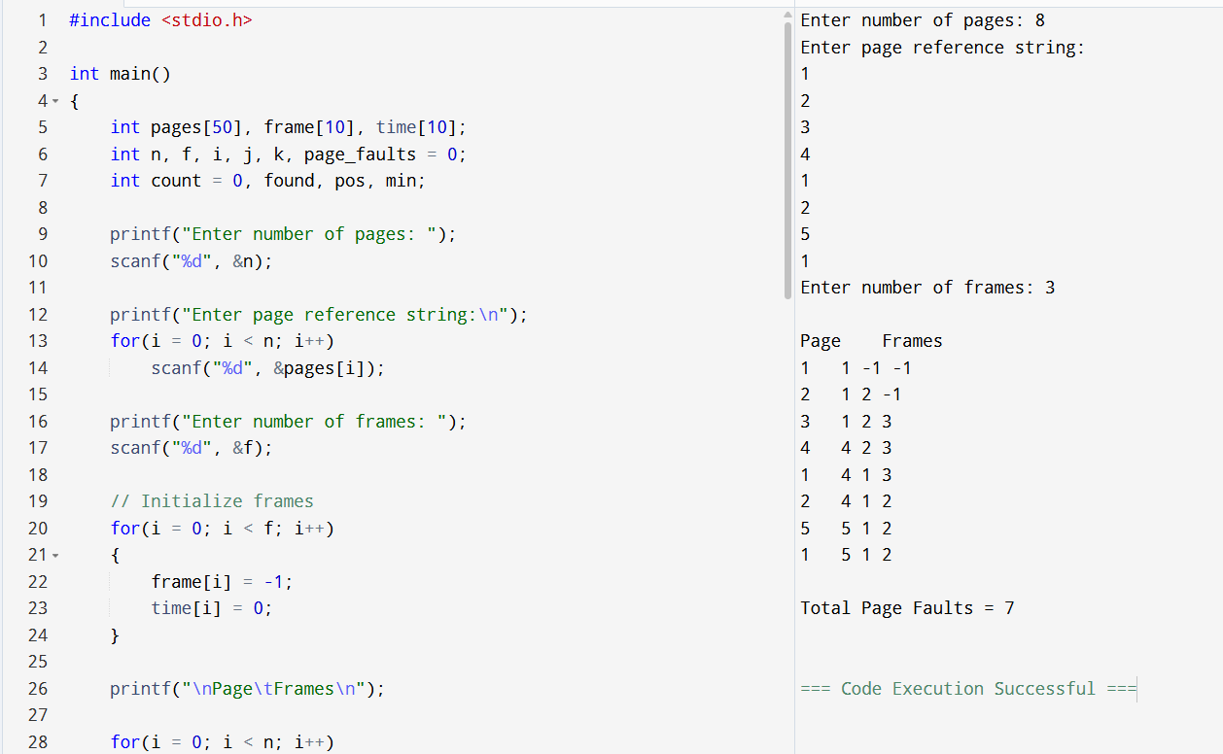
Result:
The Least Recently Used (LRU) Paging Technique was successfully simulated, and the total number of page faults was calculated correctly.
Experiment No: 22
Aim:
To simulate the Sequential File Allocation Strategy using a C program.
Algorithm:
Step 1: Start
Step 2: Enter the number of records
Step 3: Enter the records of the file
Step 4: Enter the record position to access
Step 5: Check whether the record position is valid
Step 6: Read all previous records sequentially
Step 7: Display the required record
Step 8: Stop
Source Code:
#include <stdio.h>
int main()
{
int n, i, search;
printf("Enter number of records: ");
scanf("%d", &n);
int record[n];
printf("Enter records:\n");
for(i = 0; i < n; i++)
{
scanf("%d", &record[i]);
}
printf("Enter record position to access: ");
scanf("%d", &search);
if(search < 1 || search > n)
{
printf("Invalid record position!\n");
return 0;
}
printf("\nReading records sequentially:\n");

for(i = 0; i < search; i++)
{
printf("Record %d = %d\n", i + 1, record[i]);
}
printf("\nRequired record found: Record %d = %d\n",
search, record[search - 1]);

return 0;
}

Output:
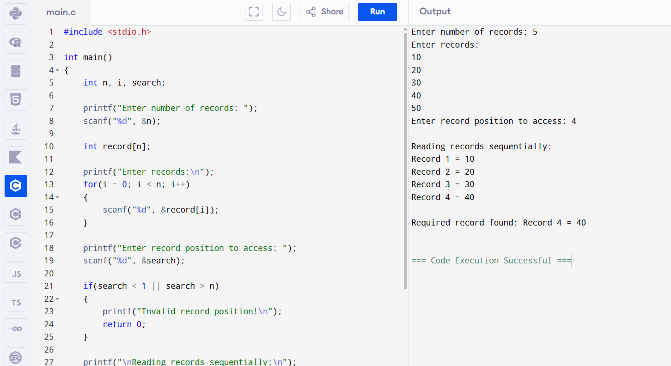

Result:
The Sequential File Allocation Strategy was successfully simulated, and the required record was accessed by reading all previous records sequentially.

Experiment No: 23
Aim:
To simulate the Indexed File Allocation Strategy using a C program.
Algorithm:
Step 1: Start
Step 2: Enter the number of file blocks
Step 3: Enter the block numbers into the index block
Step 4: Display the index block entries
Step 5: Enter the block number to access
Step 6: Check whether the block number is valid
Step 7: Display the disk location of the required block
Step 8: Stop
Source Code:
#include <stdio.h>
int main()
{
int n, i, indexBlock[20], choice;
printf("Enter number of file blocks: ");
scanf("%d", &n);
printf("Enter block numbers (index block):\n");
for(i = 0; i < n; i++)
{
scanf("%d", &indexBlock[i]);
}
printf("\nIndex Block Entries:\n");
for(i = 0; i < n; i++)
{
printf("Block %d -> %d\n", i + 1, indexBlock[i]);
}
printf("\nEnter block number to access: ");
scanf("%d", &choice);
if(choice < 1 || choice > n)
{
printf("Invalid block!\n");
}
else
{
printf("Block %d is stored at disk location %d\n",
choice, indexBlock[choice - 1]);
}
return 0;
}

Output:
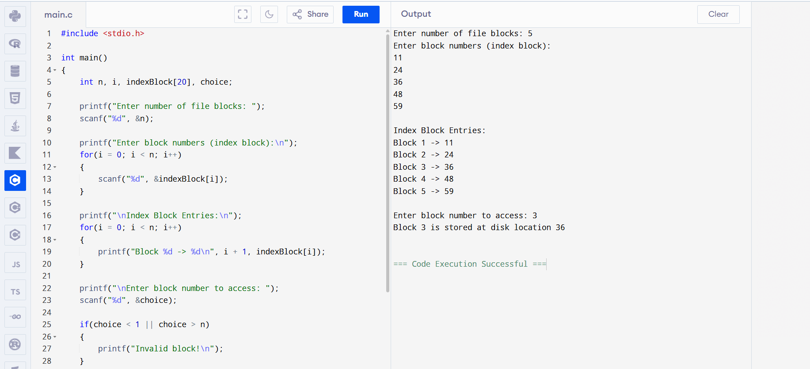

Result:
The Indexed File Allocation Strategy was successfully simulated, and the required file block was accessed correctly using the index block.

Experiment No: 24
Aim:
To simulate the Linked File Allocation Strategy using a C program.
Algorithm:
Step 1: Start
Step 2: Enter the number of file blocks
Step 3: Enter the disk block numbers
Step 4: Link each block to the next block
Step 5: Display the linked allocation structure
Step 6: Display the first and last block information
Step 7: Stop
Source Code:
#include <stdio.h>
int main()
{
int n, i;
int block[20];
printf("Enter number of file blocks: ");
scanf("%d", &n);
printf("Enter disk block numbers:\n");
for(i = 0; i < n; i++)
{
scanf("%d", &block[i]);
}
printf("\nLinked Allocation:\n")
for(i = 0; i < n - 1; i++)
{
printf("Block %d -> points to Block %d\n", block[i], block[i + 1]);
}
printf("Block %d -> NULL\n", block[n - 1]);
printf("\nDirectory Information:\n");
printf("First Block = %d\n", block[0]);
printf("Last Block = %d\n", block[n - 1]);

return 0;
}

Output:
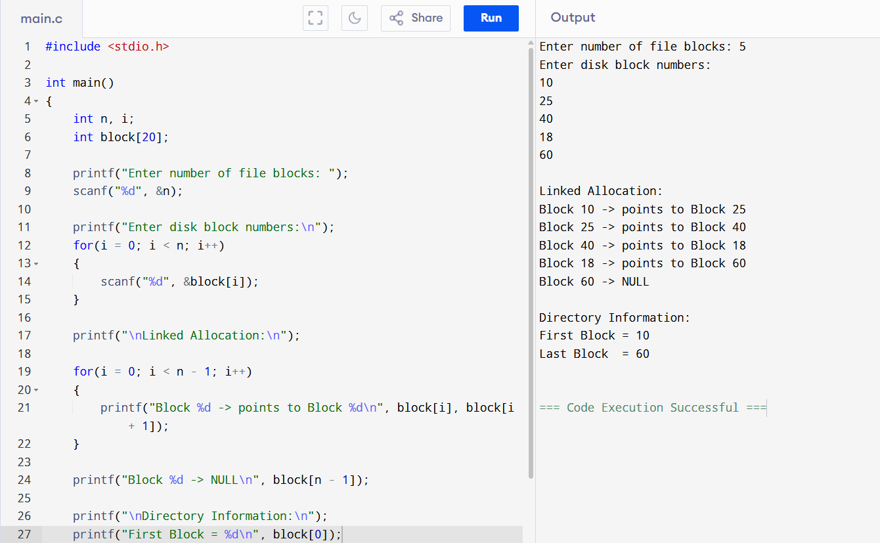

Result:
The Linked File Allocation Strategy was successfully simulated, and the file blocks were connected using pointers from one block to the next.

